
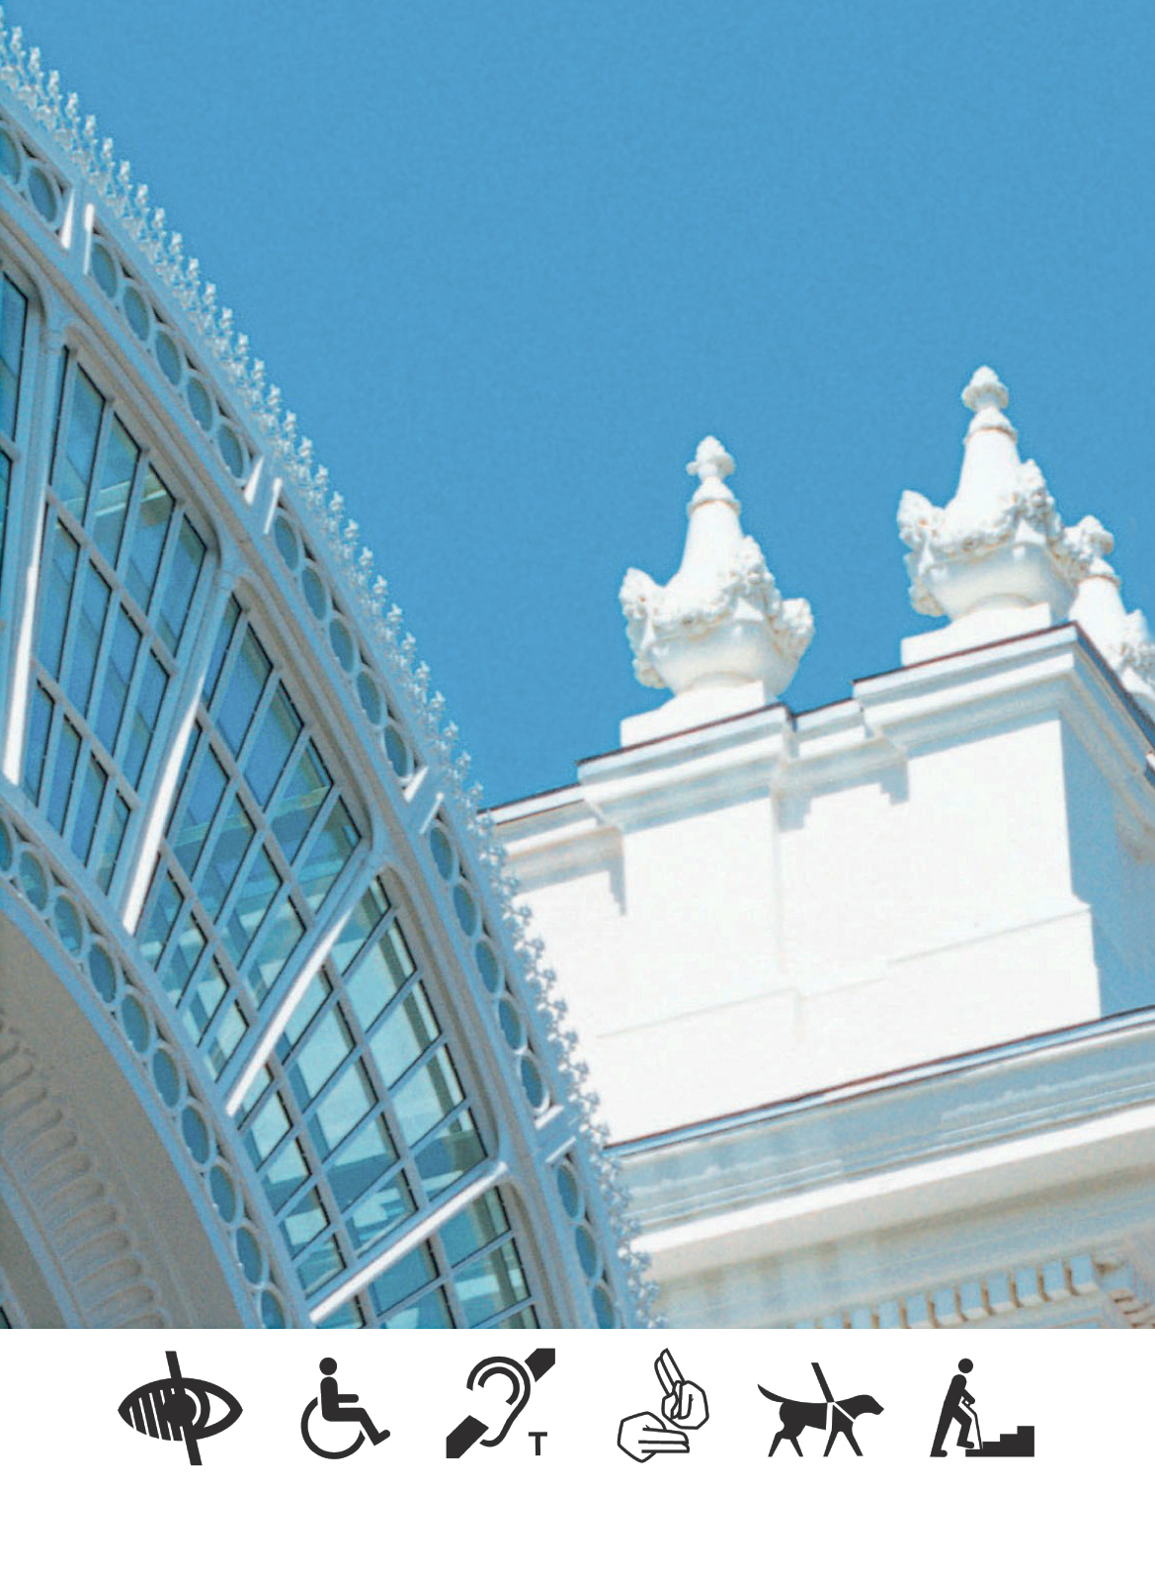
Terms and conditions
Access membership
We are committed to making your visit enjoyable and our dedicated team can advise you of our facilities and discuss any requirements.
-
Membership is open to any EU resident
who is disabled as defined by the Equality Act 2010.

The Royal Opera House Box Office Access Team reserves the right to
require proof of eligibility for the scheme.

Members who intentionally give false or misleading information will have their membership revoked.

The Royal Opera House Box Office Access Team retains the right to review
and amend the scheme without prior notice and to require members to
re-apply for membership after review.
-
Facilites and services offered to our
members include:
Access
Membership Registration
-
-
Personalized seat allocation, based on
your preferences, subject to availability.

Assistance in all aspects of your booking from our dedicated team.

Free mailing of all our Season Guides, sent to you in your preferred format.

Same-day telephone booking for Day Tickets (subject to availability), normally only available in person at the Box Office.

Personalized membership card and unique membership number.

Priority booking for British Sign Language interpreted performances.

One discounted ticket available to members who are in receipt of disability- related benefits (proof of eligibility is required).

One free companion ticket if it is essential that you are accompanied inside the auditorium throughout the performance (proof of eligibility is required - companion must be at least 18 years old).
-
-
-
-
I would like to be contacted with information on future events
presented by the Royal Opera House and its partners that may be of interest to me (in addition to the correspondence that I will receive as a Member of the Access Scheme).

I would like to be contacted with information from other organizations, approved by the Royal Opera House, which may be of interest to me.
-
-
Signature
Please sign and date your application to confirm that the information given is correct and to show that you have read the terms and conditions.
-
-
Please return this completed form to:
Box Office Access, Royal Opera House, Covent Garden, London WC2E 9DD
Signed

Date

Your
details
Companion tickets
If you require continual supervision or
assistance inside the auditorium during the performances, you may be eligible for a free companion ticket. Please see attached document for further details.
Please tick this box to apply for
free companion tickets.
Season Guide
preference
Preferred contact method
Please tick as many as applicable;
allowing us to contact you in a variety of ways will help us provide you with the best possible service.
Standard print

Large print

Audio CD Season Guide
Auxiliary aids and services
Telephone

E-mail
Post - standard print Post - large print
Assisted Hearing Facility

Performance Audio-Introduction
Access and Seating
requirements
On the night
Via post
BSL interpreted performances

Wheelchair loan
Wheelchair space

Accessible seat for wheelchair transfer
Self-propelled
Transit
Assistance dog (auditorium access
)
Discounted tickets
If you receive disability-related state
benefits, you may be eligible for a discount on the cost of your tickets.
Aisle seat: (Preference
)
Aisle on RIGHT
Aisle on LEFT No preference
Please tick this box if you would
like to apply for the reduction.
Seat with extra leg-room

Seat close to the stage
Proof of eligibility is required.

Please see attached document for further details.
Max no. of steps (0=level access)
For more information or assistance with completing this form call +44 (0)20 7304 4000 or e-mail boxofficeaccess@roh.org.uk

Please contact my personal assistant:

(name and contact details)

E-mail

Telephone No.

Address

Postcode

Other (please give details)

continue on a seperate sheet if necessary

Title and surname: Forename(s):

Companion Ticket Form
Should you wish to apply for Free Companion tickets, please ask your GP/Consultant to complete, sign and date the following questionnaire. An official stamp of authorization from the relevant Medical Practice/Consultant is required. (If you are a wheelchair user or certified blind you are automatically eligible).
The Free Companion facility is only available to Access Members who require assistance or supervision throughout the performance.
I, (name of GP), hereby confirm
that (name of individual) requires the following assistance when attending the Royal Opera House:
(PLEASE TICK ONE OPTION ONLY)
- Limited assistance
- Mobility assistance
(assistance to and from seat/during intervals)
- Continual assistance
(essential assistance/supervision throughout the performance)
I can confirm that I have made this appraisal in a professional capacity as the individual’s GP/ Consultant.
Signed Date Surgery/Practice stamp

The above criteria are subject to change in accordance with Royal Opera House disability policy. The Royal Opera House reserves the right to refuse free companion tickets where it deems necessary.
Please note, the free companion facility is applicable to one performance per production.

Discounted tickets
To qualify for discounted tickets, please provide a photocopy of your most recent disability-related state benefit document. The document you submit should be dated from within the last 12 months and not have expired.
Please find below a list of usually accepted criteria:
- Disability Living Allowance (DLA) or Attendance Allowance
- Employment & Support Allowance for a period of at least twelve months Personal Independence Payment (PIP)
- Working Tax Credit
- (with disability element only) Constant Attendance Allowance The Independent Living Fund Disabled Student’s Allowance
- Industrial Injuries Disablement Benefit War Disablement Pension
- Armed Forces Compensation Scheme (with Guaranteed Income Payment only) Vaccine Damage Payment
- Severe Disablement Allowance
This list is subject to change in accordance with
the guidelines provided by the Department for Work & Pensions. The Royal Opera House reserves the right to refuse discounted tickets where it deems necessary.
Please note, if your application is successful, the 25% concession on your own personal ticket is applicable to one performance
per production.

