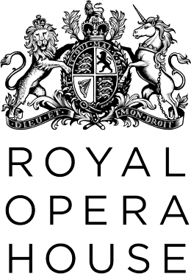 | Access  Scheme  Registration Form
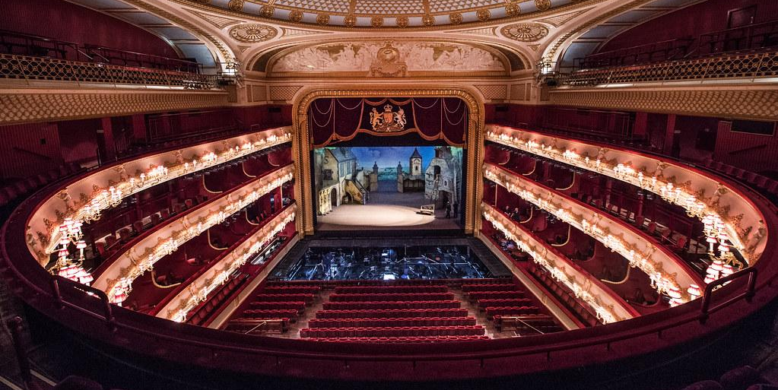
Please return this completed form to either:
Box Office Access Desk  Royal Opera House  Covent Garden  London  WC2E 9DD | or | boxoffice.access@roh.org.uk
Please contact us on +44 (0)20 7304 4000 or email boxoffice.access@roh.org.uk if you have any questions about this form, or would like to book a ticket before registering on this scheme.
Welcome

The Royal Opera House Access Scheme is a free service, and open for anyone to register. The main benefits of registering on the Access Scheme include:

- Assistance in all aspects of your booking from the Box Office team.
- Personalised seat allocation, based on your requirements.
- Mailings containing information about upcoming performances and booking periods.
- Access to the Royal Opera House Season Guide sent in your preferred format. Audio guides are available.
- Priority booking and reduced-price tickets for British Sign Language-interpreted performances.
- Reduced-price tickets for anyone in receipt of relevant disability-related state benefit (see “Discounted Tickets” section below for more information).
- One complimentary companion ticket if you require assistance or supervision during the performance (see “Companion Tickets” section below for more information).
- The option to book online, by post, by phone, or in person.

Terms and Conditions

The Royal Opera House may ask for proof of eligibility for certain aspects of the scheme, such as discounted tickets or the free companion facility. The Royal Opera House retains the right to review and amend this scheme.

Your Signature

Please sign and date your application to confirm that the information you have provided below is correct and to show that you have read the “Terms and Conditions” section above.

Signature
Date

Your Details
Title
Name
Address
Telephone
Email
How Should We Contact You?

Allowing us to contact you in a variety of ways helps us to provide the best possible service. Please choose as many as you need from the list below.

☐Telephone
☐Email
☐Post (Standard Print)
☐Post (Large Print)
☐I would like to receive Royal Opera House event and booking information
(in addition to notifications about ROH Accessibility).
☐I would like to receive Audio Guides on upcoming events and booking info
☐I would like to be contacted with information from other organisations,
approved by the Royal Opera House, which may be of interest to me.

Do you have a Personal Assistant?

If you have a personal assistant, partner, or another person who provides assistance and you would like them to book on your behalf, please include their details below.

Assistant’s Full Name

Phone Number

Email

What are your Seating Requirements?
☐ Wheelchair space
☐ Accessible seat for wheelchair transfer
☐ Seat with extra legroom
☐ Seat close to toilet
☐ Seat close to exit
☐ Aisle seat
☐ Aisle on LEFT
☐ Aisle on RIGHT
☐ No preference
☐ Assistance dog
☐ I will leave my assistance dog with a staff member during the event
Max no. of steps (0 = Step free access)

Do you have any other access requirements you would like to tell us about?

Which Facilities and Services Do You Require?

☐ Assisted Hearing Facility
☐ Audio introductions
☐ During your visit
☐ In advance of your visit (please note, this resource is online only)
☐ House Wheelchair loan

Are You Interested In Any of the Following?

☐ British Sign Language Interpreted Performances
☐ Captioned Performances
☐ Relaxed Performances
☐ Audio Described Performances
☐ Touch Tours

Discounted Tickets

☐ Please tick this box if you are applying for reduced price tickets.

To qualify for discounted tickets, please provide a copy of your most recent disability-related state benefit document. The document you submit should be dated from within the last 12 months and not have expired. Please find below some examples of relevant documentation:

- Disability Living Allowance (DLA) or Attendance Allowance
- Employment & Support Allowance for a period of at least twelve months
- Personal Independence Payment (PIP)
- Working Tax Credit (with disability element only)
- Constant Attendance Allowance
- The Independent Living Fund Disabled Students Allowance
- Industrial Injuries Disablement Benefit / War Disablement Pension
- Armed Forces Compensation Scheme (with Guaranteed Income Payment only)
- Vaccine Damage Payment
- Severe Disablement Allowance

Please note that this list is not exclusive, and we will accept any other documents that demonstrate that you receive disability-related state benefit, in accordance with the Royal Opera House policies.

If your application is successful, a 25% concession on your own personal ticket is applicable to one performance per production during each season.
Companion Tickets

☐ Please tick this box if you are applying for free companion tickets.

The Free Companion facility is available to anyone who requires assistance or supervision throughout the performance.

If you are a wheelchair user, you are automatically eligible for a free companion ticket, if you require one. If you have indicated this above, there is no need to complete the rest of this form.

If you are registered as severely sight impaired or blind, or receive DLA/PIP/Attendance Allowance at a higher or enhanced rate, you are automatically eligible for free companion tickets. Please attach a copy of your most recent document confirming this to your completed form.

If none of the above apply to you, please ask a relevant professional to complete the section below, along with either an official stamp or headed letter.

Name of relevant professional:

☐ I hereby confirm that the primary person named on this form will require Assistance or supervision throughout the performance.

I can confirm that I have made this appraisal in a professional capacity.

Signature |  | Date
Stamp

